Policy Name: Health and Safety

Purpose
The purpose of this policy is to ensure a safe, healthy and supportive environment for all employees, volunteers, gymnasts, parents, visitors and contractors. Rising Phoenix Gymnastics CIC is committed to preventing injury and illness by promoting safe working practices and complying with all relevant health and safety legislation.

Scope
This policy applies to everyone working for or representing Rising Phoenix Gymnastics CIC, including directors, employees, volunteers, contractors, visitors and anyone attending club activities or events.

Principles
🛡️ Providing a safe environment
⚠️ Identifying and managing risks
🧑‍🏫 Providing training and supervision
🗣️ Encouraging hazard reporting
📋 Complying with health and safety legislation
🤝 Promoting shared responsibility

Policy Statement
Rising Phoenix Gymnastics CIC is committed to providing and maintaining a safe, healthy and supportive environment for everyone using our facilities. We will achieve this by:
- Providing safe premises and equipment;
- Completing and reviewing risk assessments;
- Delivering appropriate training and supervision;
- Providing clear health and safety information;
- Maintaining emergency procedures;
- Encouraging the reporting of hazards, accidents and near misses;
- Regularly reviewing health and safety arrangements.

Responsibilities
The Company: General & Work Place:
- Ensuring any health and safety representatives receive appropriate training to carry out their functions effectively.
- Providing safe arrangements for the use, handling, storage and transport of articles and substances.
- Providing a health and safety induction and appropriate safety training to employees/volunteer role
- Promoting effective communication and consultation between the RPG CIC and staff concerning health and safety measures.
- Regularly monitoring and reviewing the management of health and safety at work, making any necessary changes and bringing those to the attention of all staff.
The Company: Emergencies:
- Identifying health and safety place of work and safe entry and exit arrangements, including during an emergency situation.
- Identifying health and safety place of work and safe entry and exit arrangements, including during an emergency situation.
Providing adequate information, instruction, training and supervision to enable all staff to work. RPG CIC will give you the opportunity to ask questions and advise who best to contact in respect if you are unaware about how to safely carry out your work.

The Company: Equipment Safety:
- Providing and maintaining working areas, equipment and systems and, where necessary, appropriate protective clothing.
The Company: First Aid:
- Regular checks ensuring first aid supplies are replenished and not out of date
  - Including refrigeration for ice packs
- Ensure first aid book is accessible and space to complete
- Provide a list of qualified first aiders

The Company: Health Alerts:
- If an epidemic or pandemic alert is issued, providing instructions, arrangements and advice to staff to the organisation of business operation and steps to be taken to minimise the risk of infection.
- Overall responsibility for health and safety lies with the RPG CIC Directors. They have appointed themselves as the Health and Safety Officer with day-to-day responsibility for health and safety matters.

Employees/volunteers:General & Workplace:
- Take reasonable care of your own health and safety and that of others who may be affected by their acts or omissions.
- Co-operate with any health and safety instructions and rules, including instructions on the safe use of equipment.
- Keep health and safety issues in the front of your minds and take personal responsibility for the health and safety implications of their own acts and omissions.
- Keep the workplace tidy and hazard-free
- Report all health and safety concerns to RPG CIC Directors promptly, including any potential risks, hazards or malfunctioning of equipment, however minor or trivial they may seem
- Co-operate in RPG CIC’s investigation of any incident or accident which either has led to injury or which, in the RPG CIC’s opinion, could have led to injury.
Employees/volunteers:Emergencies:
- Familiarise yourself with the instructions about what to do if there is a fire which are available in this staff handbook – read ‘Fire Safety Policy’ section.
- Ensure they are aware of the location of fire extinguishers, exits, alternative ways of leaving the building and safety locations once left the building.
- Comply with the instructions provided in the Fire Safety Policy and ensure visitors do the same.
- Co-operate in fire drills and take them seriously and ensure any visitors do the same.
- Ensure fire exits, notices and exit signs are not obstructed or hidden at any time.
- Notify RPG CIC Directors immediately or any circumstances (for example, impaired mobility) which might hinder or delay an evacuation in a fire. This will allow RPG CIC Directors to discuss a personal evacuation plan for you, which will be shared with senior members of staff and colleagues working with/near you.
Employees/volunteers:Equipment Safety:
- Use equipment as directed, following any instructions given by representatives of management or contained in any written operating manual or instructions for use, and adhering to any relevant training.
  - Report any fault with, damage to, or concern about any equipment (including health and safety equipment) or its use to RPG CIC Directors, who is responsible for maintenance and safety of equipment in the premises.
  - Ensure health and safety equipment is not interfered with.
  - Do not attempt to repair equipment unless suitably trained and authorised to do so
Employees/volunteers: First Aid:
- Promptly report any accident at work involving personal injury, however, trivial, to a senior member of staff/first aider so that details can be recorded in the Accident Book. They must also co-operate with any associated investigation.
- Familiarise themselves with the details of first aid facilities and trained aiders, which are available from the health and Safety Officer.
- RPG CIC Directors is responsible for investigating any injuries or work-related illnesses, preparing and keeping accident records, and for submitting reports under the Reporting of Injuries Diseases and Dangerous Occurrences Regulations 2013 (RIDDOR), where required.
Employees/volunteers: Health Alerts:
- If an epidemic or pandemic alert is issued, all staff must comply and co-operate with all instructions, arrangements and advice issued by the employer as to the organisation of business operations and steps to be taken by staff to minimise the risk of infection. Any question should be referred to RPG CIC Directors

Procedure
The flowchart below summarises the Health & Safety reporting procedure. Further guidance is provided in the detailed procedure section.
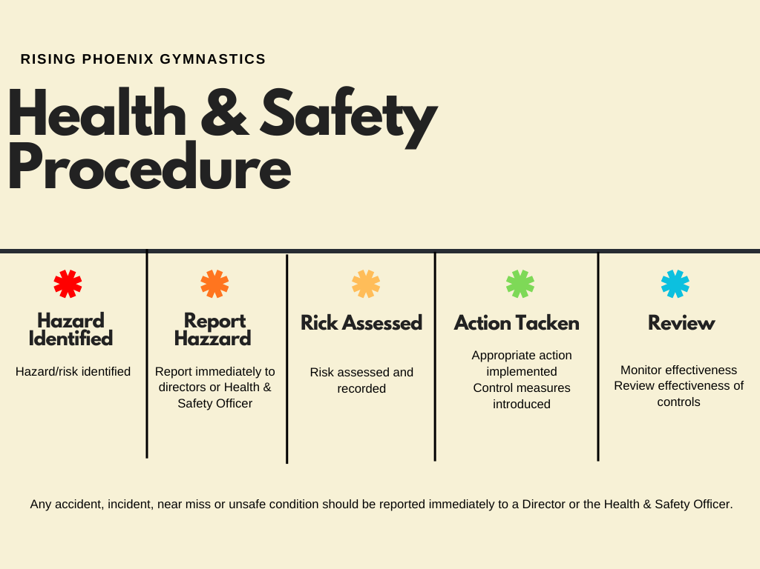

Detailed Procedure

Reporting Hazards
  - Report any hazard, unsafe condition or near miss immediately to a Director or Lead Coach.
    - Or Lead Coach to pass onto RPG CIC Director

Equipment Safety
  - Identify and report any misuse, hazards or breakages to RPG CIC Director or Lead Coach to pass onto RPG CIC Director
  - Do not use equipment if a hazard has been identified until given the go ahead from a RPG CIC Director
  - Equipment should be removed from use where it is unsafe to continue using it.

Accidents & First Aid
  - Promptly report accidents to the lead coach or RPG CIC Director
  - Only qualified first aiders to perform any form of first aid
  - First aiders are listed in the club
  - Any first aid given must be logged in the accident book
  - RPG CIC Directors to assess if RIDDOR report is needed
    - Complete RIDDOR report

Fire & Emergency Procedures
  - Identify risk
  - Trigger nearest alarm
  - Notify senior member of staff
  - Follow instructions from the Lead Coach or Director and assist with evacuation where requested.
  - Senior members of staff call 999

Health Alerts
  - RPG CIC will communicate and comply with all instructions/arrangements provided to all members

Related Documents
- Staff Handbook
- Fire Safety Policy
- First Aid Policy
- Risk Assessment Guidance
- Safeguarding Policy

