Policy Name: Fees, Cancellations & Refunds Policy

Purpose
The purpose of this policy is to provide clear and consistent arrangements for the payment of fees, cancellations and refunds at Rising Phoenix Gymnastics CIC.
It aims to ensure that members and parents/carers understand their payment responsibilities, the notice required when cancelling a place, and the circumstances in which refunds or credits may be considered.

Scope
This policy applies to all members, parents/carers and participants of Rising Phoenix Gymnastics CIC who are responsible for the payment of fees for classes, camps, events or other activities provided by the club.
It covers arrangements relating to fees, payment deadlines, late payments, cancellations, notice periods, refunds and credits.
Principles
Rising Phoenix Gymnastics CIC aims to manage fees, cancellations and refunds in a fair, consistent and transparent manner.
Members and parents/carers will be provided with clear information regarding fees and payment arrangements. Fees should be paid by the stated due date, and the required notice should be provided when cancelling a place.
Any refunds, credits, late payment charges or exceptional circumstances will be considered and applied consistently in accordance with this policy.

Policy Statement
Rising Phoenix Gymnastics CIC requires all fees to be paid in accordance with the payment terms communicated to members and parents/carers.
Places within classes are reserved for individual gymnasts and therefore remain chargeable until the required cancellation notice has been provided and the notice period has ended.
Late or outstanding payments may be subject to additional charges in accordance with this policy. Refunds or credits will only be issued where applicable under this policy or where agreed by a Director in exceptional circumstances.
The club will ensure that fees, cancellation requirements and any applicable charges are communicated clearly and applied fairly and consistently.

Responsibilities
Directors are responsible for:
- Setting and reviewing club fees, payment terms and any applicable late payment charges.
- Ensuring this policy is applied fairly and consistently.
- Considering exceptional circumstances where a refund, credit or alternative arrangement may be appropriate.
- Approving any changes to fees or payment arrangements.
Administration/Finance staff are responsible for:
- Issuing invoices and maintaining accurate payment records.
- Allocating payments received to the appropriate accounts.
- Sending payment reminders and following up outstanding fees.
- Applying agreed late payment charges in accordance with this policy.
- Recording cancellations and ensuring the correct notice period is applied.
- Referring disputes or exceptional circumstances to a Director where necessary.
Members and parents/carers are responsible for:
- Paying fees by the stated due date.
- Ensuring their payment details and contact information are kept up to date.
- Providing the required notice when cancelling a place.
- Contacting the club promptly if they are experiencing difficulties making a payment.

Procedure
Payment of Fees
Fees must be paid by the due date stated on the invoice or payment request. Parents/carers are responsible for ensuring payments are made on time and for contacting the club promptly if there is a problem with payment.
A gymnast’s place remains chargeable while they are registered for their class, including during any applicable cancellation notice period.
Late or Outstanding Payments
Where payment has not been received by the stated due date, the club may issue a payment reminder.
- Invoice reminders are sent 3 and 5 days after the due date
- Fees remaining unpaid 7 days after the due date will receive a £5 late payment charge.

Cancelling a Class Place
One month’s notice is required when cancelling a gymnast’s regular class place.
Notice must be provided in writing to the club. Fees remain payable throughout the notice period, whether or not the gymnast attends their sessions.
The cancellation will take effect once the required notice period has ended.
Parents/carers wishing to cancel a gymnast’s regular class place must provide at least one month’s notice before the next fee due date, which is the 28th of each month.
Notice must be provided in writing to the club. Fees remain payable during the applicable notice period, whether or not the gymnast attends their sessions.
Where the required notice has not been provided before the next fee due date, the next month’s fees will remain payable.
For example: cancel by 28th September → October is the notice month/final payment → place ends the last day of October.
If cancelled on 29th September, the notice deadline has been missed and the last day of November would become the final paid month.
Refunds and Credits
Fees already paid are normally non-refundable where a gymnast chooses not to attend a scheduled session.
Refunds or credits may be considered where:
- the club cancels a session and no suitable alternative is provided;
- an incorrect payment or overpayment has been made;
- exceptional circumstances apply and a Director agrees that a refund or credit is appropriate.
Any refund or credit will be considered on the individual circumstances and in accordance with this policy.
Club-Cancelled Sessions
Where Rising Phoenix Gymnastics CIC cancels a session, the club will communicate with affected members as soon as reasonably practicable.
Where appropriate, the club may offer a replacement session, credit or refund. The arrangement offered may depend on the reason for cancellation and the circumstances involved.
Camps, Competitions, Events and Additional Activities
Payment and cancellation arrangements for camps, competitions, events or other separately booked activities may differ from regular class fees.
Any specific payment, cancellation or refund terms will be communicated where necessary and will apply to that activity.
Exceptional Circumstances
Rising Phoenix Gymnastics CIC recognises that exceptional circumstances may occasionally arise.
A Director may exercise reasonable discretion when considering payment arrangements, cancellation notice, refunds or credits where circumstances justify doing so. Any exception should be recorded and applied fairly.
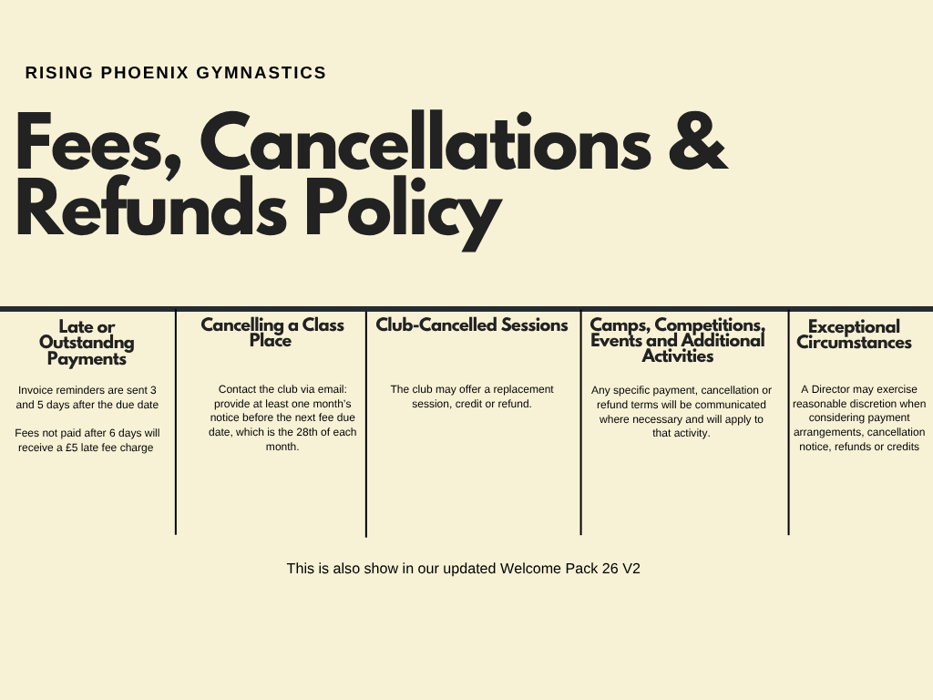

Related Documents
Welcome Pack

