Policy Name:Equality, Diversity & Inclusion

Purpose
The purpose of this policy is to promote equality, diversity and inclusion throughout Rising Phoenix Gymnastics CIC. We are committed to creating an environment where everyone is treated fairly, with dignity and respect, and where discrimination, harassment and victimisation are not tolerated.

Scope
This policy applies to all employees, volunteers, gymnasts, parents, contractors and anyone representing Rising Phoenix Gymnastics CIC.

It applies to recruitment, employment, training, volunteering, participation in gymnastics activities and all club events.

Principles
The Company is committed to:
• Equality of opportunity
• Inclusion
• Respect
• Diversity
• Fair treatment
• Compliance with the Equality Act 2010

Policy Statement
Rising Phoenix is committed to achieving its equality duty, which is set out in the Equality Act 2010 by having due regard to the need to:
- Eliminate discrimination
- Advance equality
- Foster good relations
We believe that diversity strengthens our club, inclusion creates opportunity, and respect enables everyone to reach their full potential.

Responsibilities

The Company:
- To create an environment in which individual differences and the contributions of all team members are recognised and valued.
- To create a working environment that promotes dignity and respect for every member of RPG CIC.
- To not tolerate any form of intimidation, bullying, or harassment, and to discipline those that breach this policy.
- To make suitable training, development and progression opportunities available to all members.
- To promote equality in the workforce, which RPG CIC believes is good management practice and makes sound business sense.
- To encourage anyone who feels they have been subject to discrimination to raise their concerns so we can apply corrective measures
- To encourage employees to treat everyone with dignity and respect.
Employees and volunteers are expected to:
- Treat everyone with dignity and respect.
- Challenge discrimination appropriately.
- Promote an inclusive environment.
- Report concerns promptly.
- Follow this policy and the Staff & Volunteer Code of Conduct.
RPG CIC Equality and Diversity Policy will be monitored and reviewed annually to ensure that equality and diversity is continually promoted.

Procedure
Anyone who believes they have experienced or witnessed discrimination, bullying, harassment or victimisation is encouraged to raise their concerns as soon as possible. 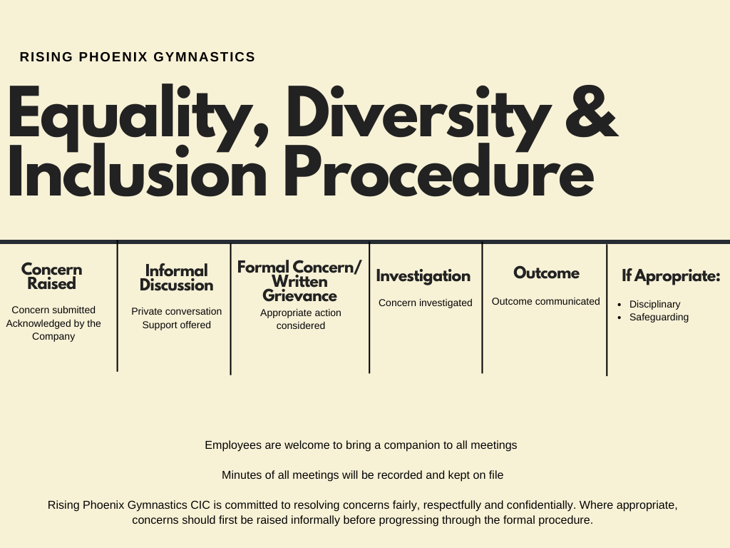

Monitoring & Review
This policy will be monitored throughout the year and formally reviewed annually, or sooner where legislation or organisational needs change.

Related Documents
- Staff Handbook
- Staff & Volunteer Code of Conduct
- Grievance Policy
- Disciplinary Policy
- Safeguarding Policy
- Complaints Procedure
- Whistleblowing Policy

