Policy Name: Extreme Temperature Policy

Purpose
Rising Phoenix Gymnastics CIC is committed to providing a safe and comfortable environment for gymnasts, staff, volunteers and visitors.
Extreme temperatures can increase the risk of illness, injury and reduced concentration. This policy sets out the measures that will be taken when the temperature within the facility becomes unusually high or low.
The temperature thresholds within this policy are internal operational thresholds established by Rising Phoenix Gymnastics CIC as part of its approach to managing risk. They should not be interpreted as statutory maximum or minimum temperatures.

Scope
This policy applies to:
- All gymnastics classes and training sessions
- Preschool and parent-and-toddler activities
- Holiday camps
- Parties and events
- Staff, volunteers, gymnasts and visitors
Temperature Monitoring
During periods of particularly hot or cold weather, the temperature within the gym will be monitored.
Temperatures should be taken from a representative area of the facility and not immediately beside a heater, fan, open door or direct sunlight where this could give an inaccurate representation of general conditions.
Where temperatures approach the action levels within this policy, they should be checked regularly and relevant action recorded.
The person responsible for the session must consider the temperature alongside other factors including:
- Humidity
- Air movement and ventilation
- Duration and intensity of activity
- Age of participants
- Access to drinking water
- Individual vulnerabilities
- Whether conditions are improving or worsening

High Temperatures
Below 30°C – Normal Operations
Sessions may continue as normal.
During warm weather, coaches should encourage regular hydration and make appropriate use of ventilation, fans and rest periods.
30°C to 32°C – Increased Precautions
Sessions may continue, but coaches should:
- Increase opportunities for drink breaks
- Monitor gymnasts for signs of heat-related illness
- Make maximum safe use of available ventilation
- Consider reducing particularly strenuous or prolonged activity
- Allow additional rest periods where required
32°C to 34°C – Reduced Activity
Activity should be modified to reduce physical exertion.
Coaches should:
- Reduce strenuous and prolonged gymnastics
- Increase rest and hydration breaks
- Make use of the coolest suitable areas available
- Closely monitor participants and staff
- Consider alternative lower-intensity activities
For holiday camps, a greater proportion of the session should be moved to crafts, games and other low-intensity activities.
34°C to 35°C – No Strenuous Gymnastics
Strenuous gymnastics activity should cease.
Where appropriate, holiday camps may temporarily continue using quiet, low-intensity activities provided that children and staff remain comfortable and can be adequately supervised.
The temperature should be monitored regularly.
The person responsible for the session should assess whether early collection, cancellation or closure is appropriate, particularly where the temperature continues to rise or adequate cooling cannot be achieved.

35°C and Above – Suspension of Activities
Rising Phoenix Gymnastics CIC will normally suspend activities when the indoor temperature reaches 35°C.
For holiday camps or activities where children are already in attendance, parents/carers should be contacted and asked to arrange collection as soon as reasonably practicable.
Children must continue to be appropriately supervised in the coolest available safe area until collected.
Activities may be suspended before 35°C where conditions are considered unsafe or participants or staff are struggling with the heat.

Low Temperatures
16°C and Above – Normal Operations
Sessions may normally continue.
13°C to 16°C – Increased Precautions
Sessions may continue following assessment of conditions.
Coaches should consider:
- Appropriate warm-up periods
- Keeping participants moving where appropriate
- Additional clothing during periods of inactivity
- Limiting prolonged periods sitting or waiting
- The age of participants
- Whether the temperature is falling
Particular consideration should be given to preschool-aged children and activities involving extended periods of low physical activity.
Below 13°C – Suspension/Modification
Gymnastics sessions should not normally operate where the indoor temperature is below 13°C.
Where the temperature cannot be increased to a suitable level, sessions should be cancelled or suspended.
For camps or events already in progress, alternative arrangements may be considered where a suitably warm area is available.
Rising Phoenix Gymnastics CIC may suspend activities at a higher temperature where conditions are considered unsuitable or unsafe.

Holiday Camps

As children attending holiday camps may remain at the facility for several hours, additional consideration must be given to prolonged exposure to extreme temperatures.

Camp activities may therefore be modified before normal classes would be cancelled.

This may include:

Reducing gymnastics time

Increasing craft and quiet activities

Increasing drink and rest breaks

Moving activities to cooler or warmer areas

Requesting early collection

Parents/carers should be informed as soon as reasonably practicable where early collection is required.Signs of Heat-Related Illness

Coaches and staff should remain alert for symptoms including:

Headache

Dizziness

Unusual tiredness or weakness

Feeling sick or vomiting

Excessive sweating

Pale or clammy skin

Muscle cramps

Confusion or changes in behaviour

Anyone showing concerning symptoms must stop participating immediately and appropriate first-aid procedures should be followed.

Emergency medical assistance should be sought where required.Signs of Cold-Related Illness
Staff should remain alert for symptoms including:
- Persistent or excessive shivering
- Unusual tiredness
- Poor coordination
- Confusion
- Pale or unusually cold skin
- Difficulty communicating normally
Anyone showing concerning symptoms must stop participating and appropriate first-aid procedures should be followed.

Authority to Modify or Cancel Sessions
The coach or staff member responsible for the session has authority to immediately reduce or stop activity where they believe conditions present a risk to participants.
Where practicable, decisions regarding full cancellation, closure or early collection should be communicated to the designated manager/director.
Safety takes priority over maintaining the scheduled activity. Staff do not need to wait for a specific temperature threshold where they reasonably believe conditions have become unsafe.

Communication With Parents/Carers
Where sessions are cancelled or early collection is required due to temperature, parents/carers will be contacted using the club's usual communication methods.
Where possible, reasonable notice will be provided. However, rapidly changing weather or indoor conditions may require decisions to be made at short notice.Recording Incidents and Decisions
Where activities are significantly modified, cancelled or ended early because of temperature, the following should be recorded where appropriate:
- Date and time
- Recorded temperature
- Relevant conditions
- Action taken
- Any illness or first-aid incidents
- Decision to cancel, close or request early collection

Procedures
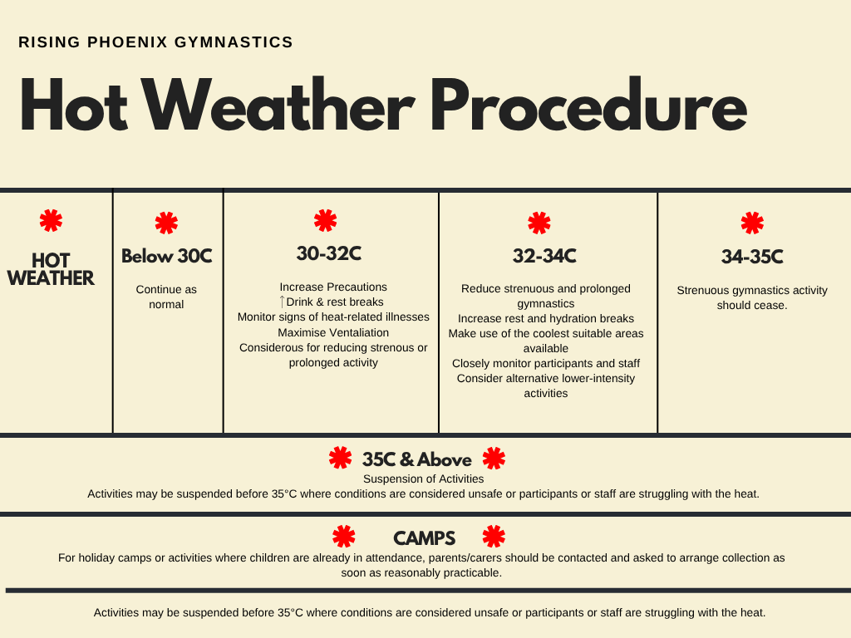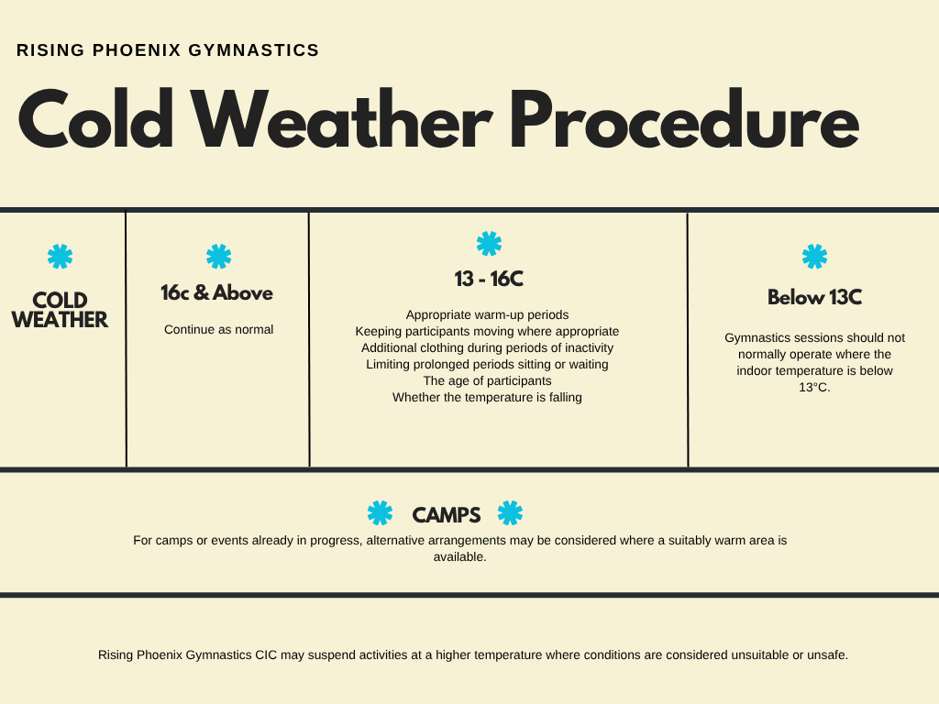
Review - This policy will be reviewed periodically and following any significant temperature-related incident, change in guidance or experience indicating that the existing procedures should be amended.

