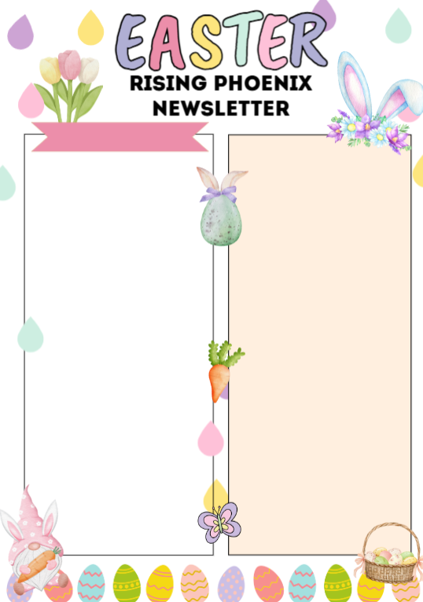
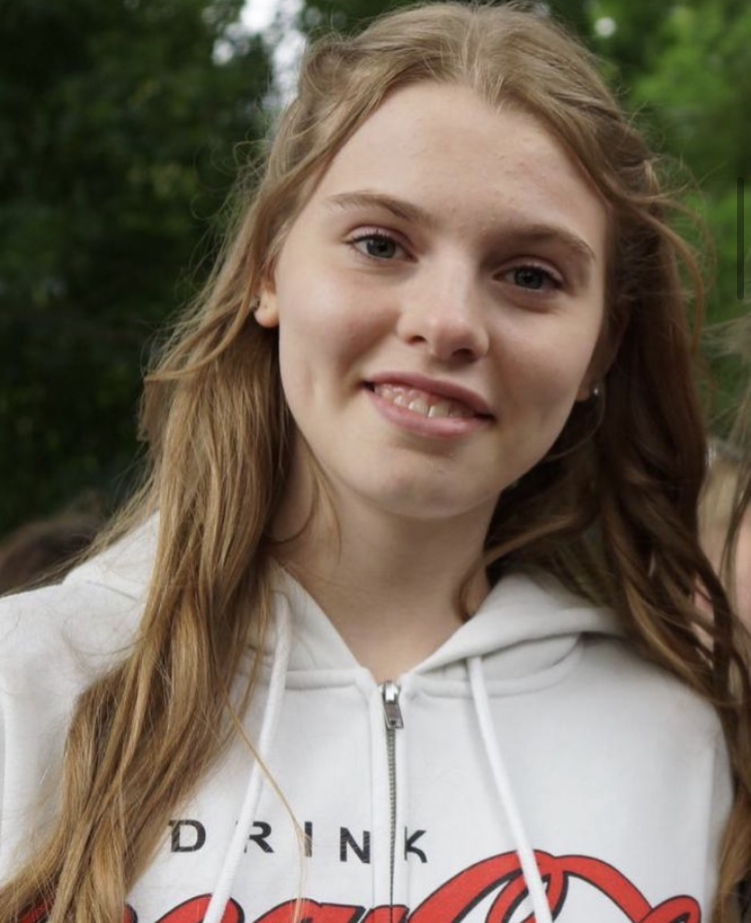


Our program is split into three sections.
We have our Glowing Embers Pre-School Program that caters from baby classes to the final year of preschool.
Our Rising Flames Recreational Program caters from beginners from age 4 up to our advanced recreational squads who are up to age 13 training up to 3 hours a week.
And finally Team Phoenix which is our squad program. This program is invite only. It covers girls and boys ranging from 4 to 15 years old. These train from 2 hours a week to 16 hours a week.
Competing in friendly local competitions to the British Gymnastics Grades program.
Our logo can be split into 3 to encompass each integral part of our program.

Did you know?
Charlotte Cattell
- Charlotte is one of our main recreational Coaches, she also coaches pre school
Staff Highlight
We have our Summer Competition coming up - 17/18th May. This years theme is Candy land
It is suitable for any level and age of gymnast. It is all about showing off what you have learnt and having fun!
We have a 4 piece competition in April this is the first 4 piece for a lot of our Dinky Squad.
- Favourite thing to coach-Floor
- Hobbies outside gymnastics- Dancing is a big part of Charlottes life and she has received many offers for Dance college in September!
Upcoming Events
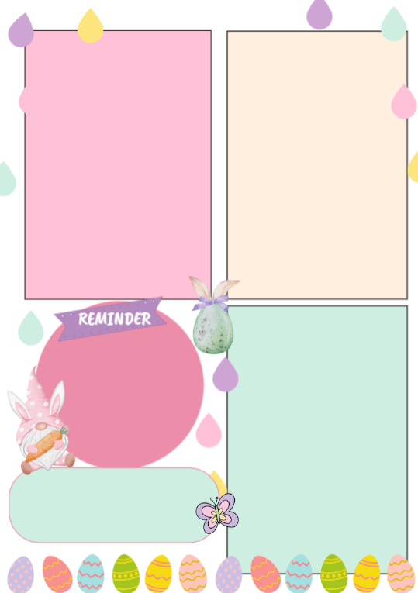



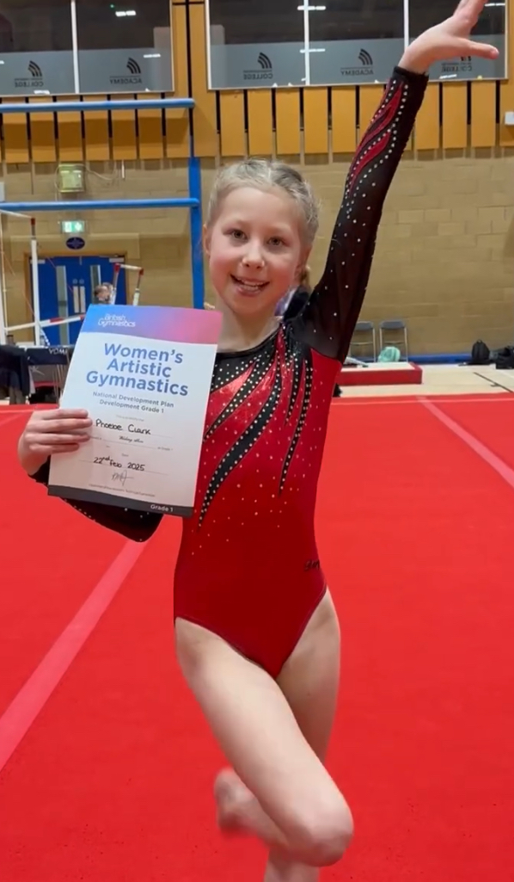
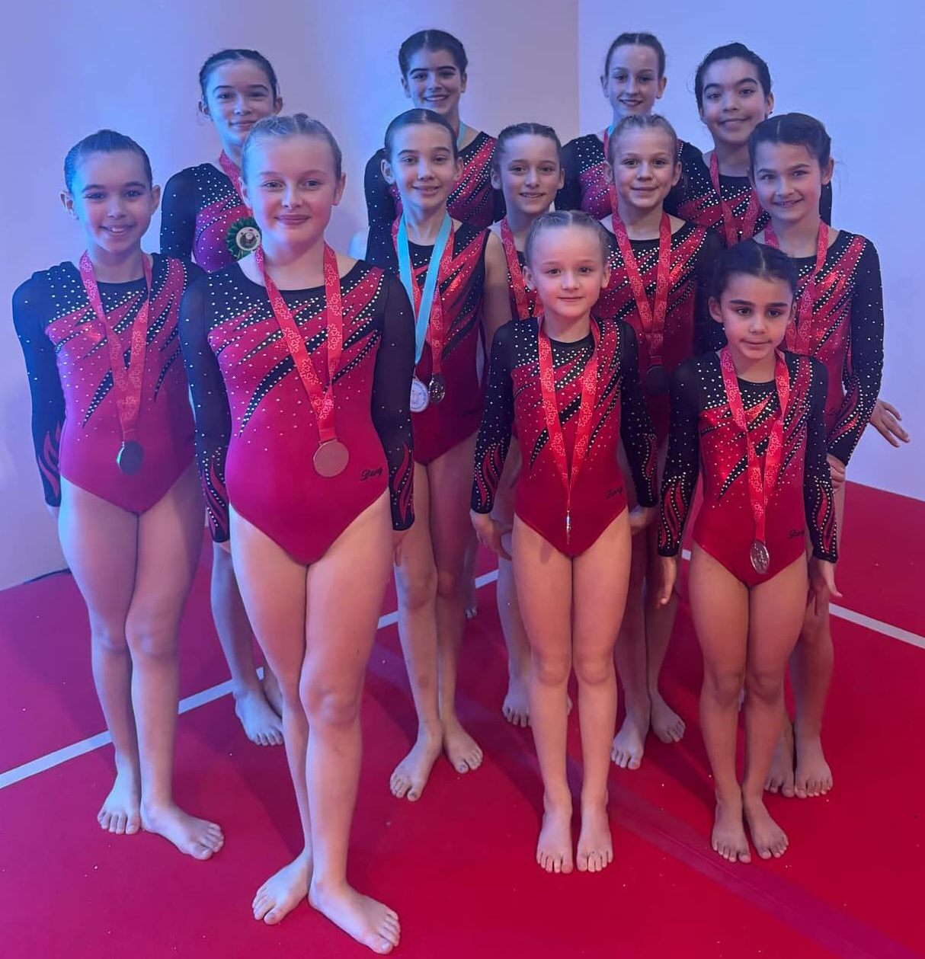
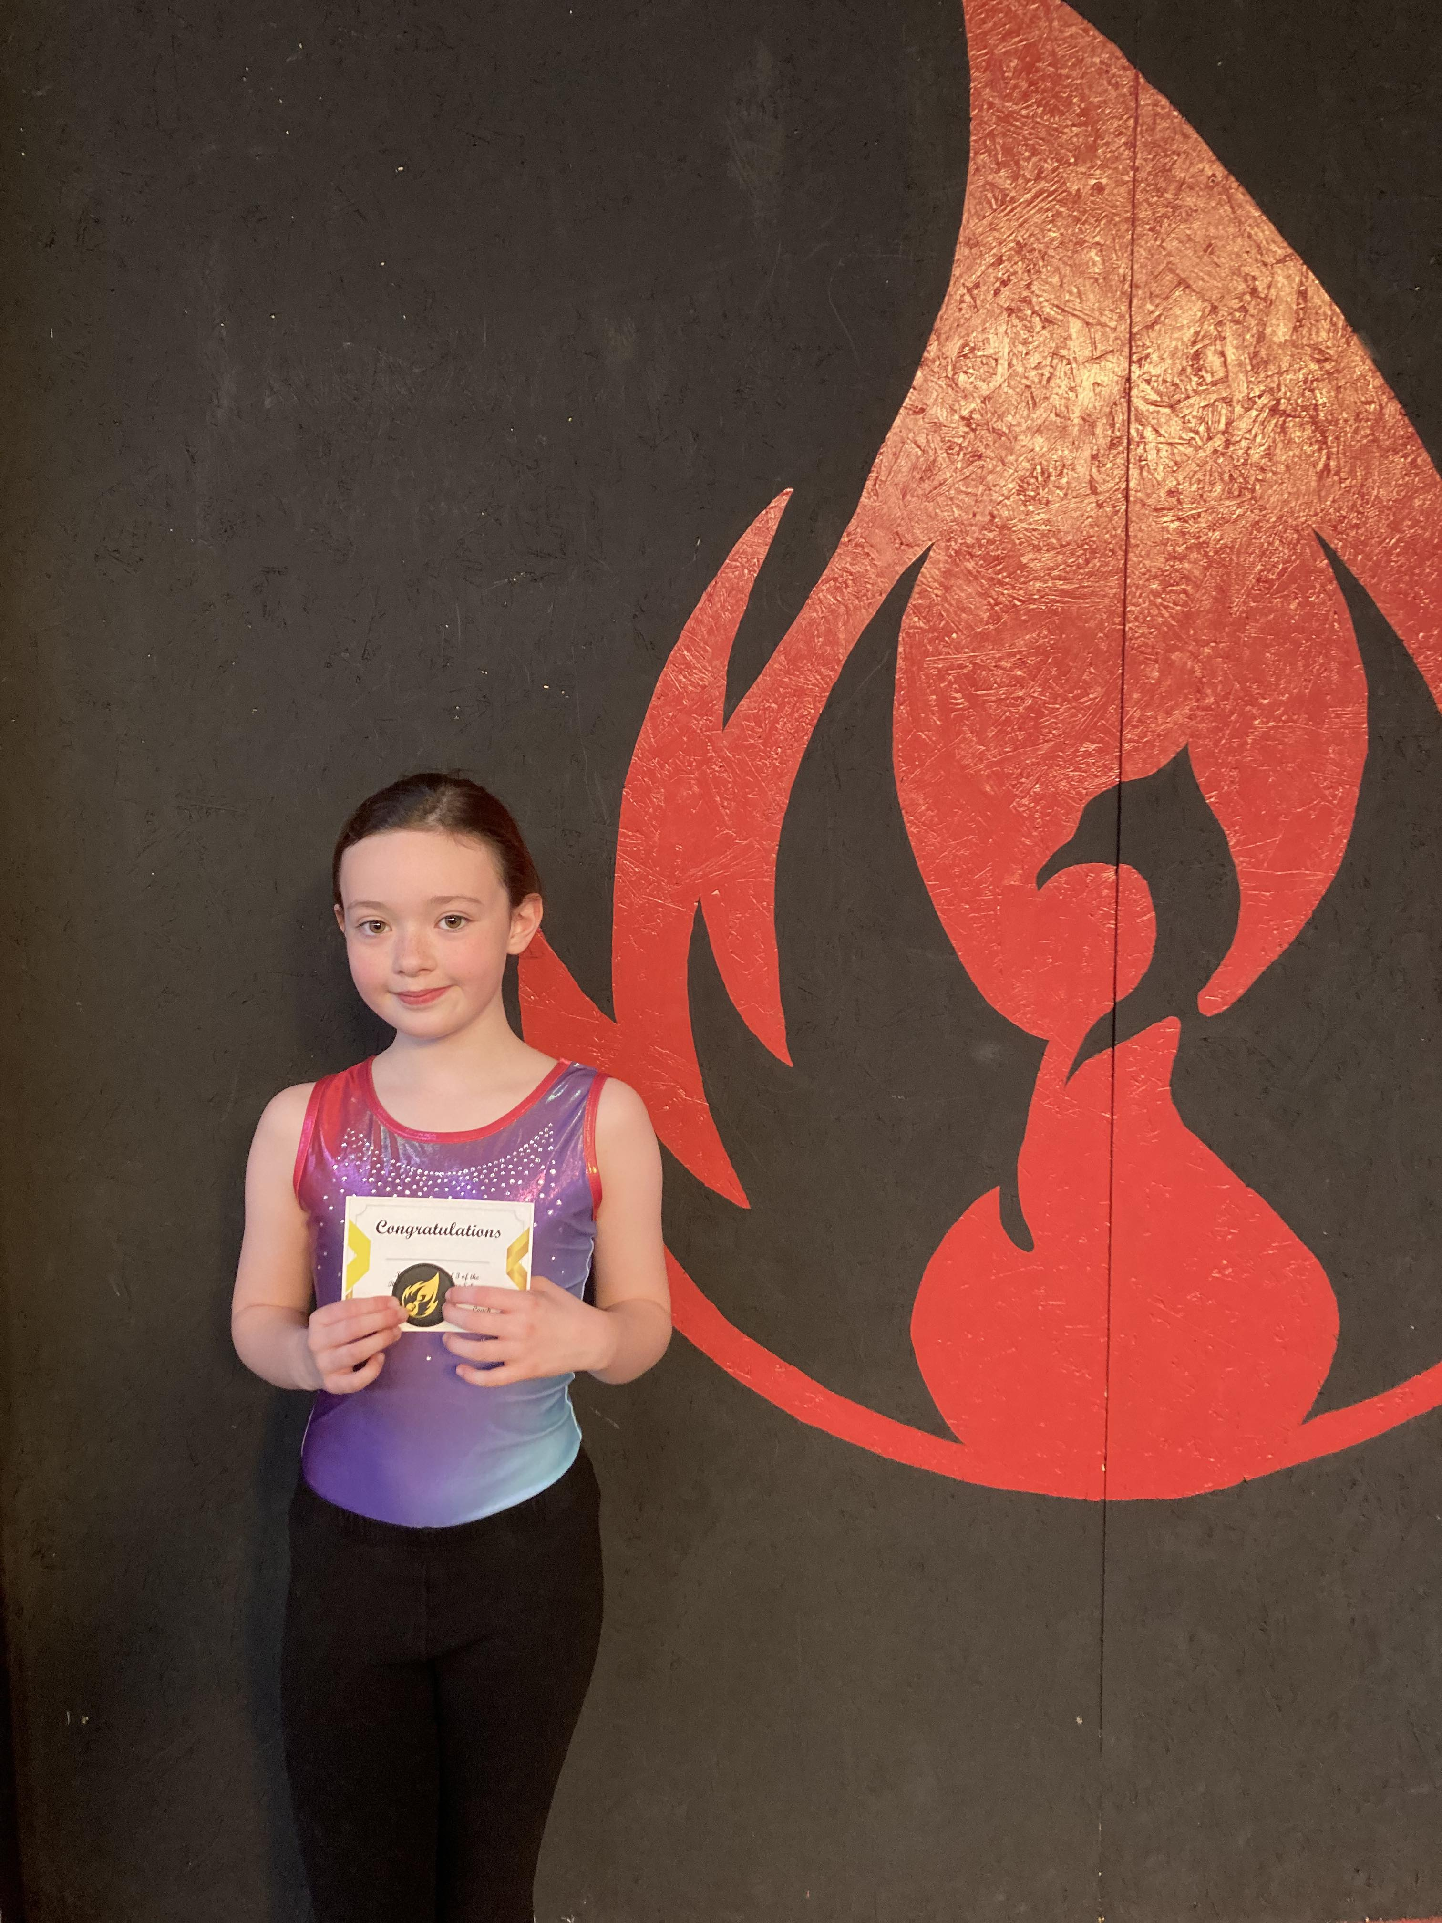
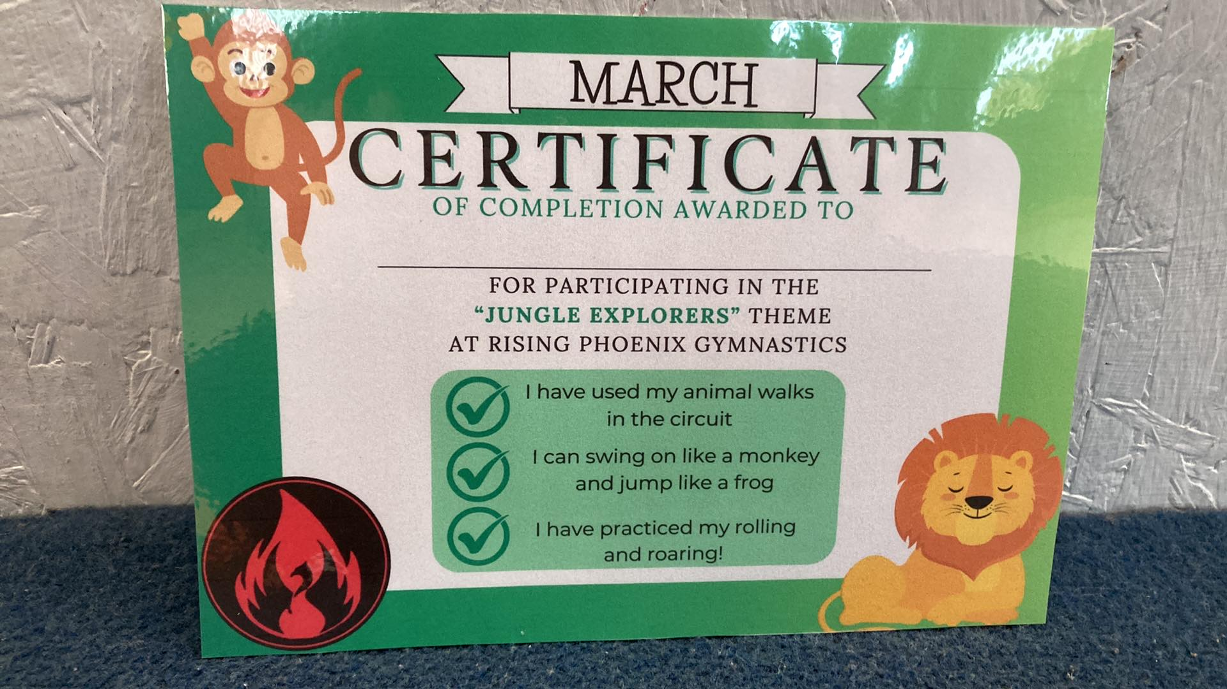
Last month was our Jungle Theme our Pre-schoolers learnt to swing like monkeys, stomping like elephants, balancing like flamingo’s and roaring like lions!
There has been some changes to the coaches on our Recreational Program, We have said a sad goodbye to Ebony we wish her the best of luck and hope to welcome her back one day.

Head Coach Amy and Head of Rec and Pre School Holly will now be on the recreational classes alongside Charlotte and Michaela.

We have also added 2 more 2 hour advanced classes for ages 4-6 and 6-9. These are invitation only. Both groups have shown huge progress over the last few months.

At the end of February Phoebe competed in her first Development Grades and passed at “working above’ She also smashed her Grades warm up winning a gold on the vault!

What’s been happening with our Glowing Embers Pre School Program?
Rising Flames Changes
What’s been Happening with our Team Phoenix Squad Program?
Our Gymnasts from both of our squad pathways competed at Winter Wonderland winning lots of medals and showing amazing competition etiquette and sportsmanship.
Closing date for Candyland Competition is Saturday 19th April
The club is closed
Bank Holiday
Monday 21st April
We have been working on our badges over the last term as well as progressing through our basics.
We enjoyed our St Patricks Day themed Parents Watching week, we love showing you guys how much they have all progressed.
What’s been happening with our Glowing Embers Pre School Program?
What’s been happening with our Rising Flames Program?
What’s been happening with our Glowing Embers Pre School Program?

