Policy Name: Safeguarding Policy

Purpose
The purpose of this policy is to safeguard and promote the welfare of all children, young people and adults at risk involved with Rising Phoenix Gymnastics CIC. We are committed to providing a safe, supportive and inclusive environment where everyone can participate free from abuse, neglect, bullying, discrimination or exploitation.

Scope
This policy applies to all directors, employees, coaches, volunteers, welfare officers, gymnasts, parents, carers, contractors and visitors involved with Rising Phoenix Gymnastics CIC.
It applies to all gymnastics sessions, competitions, camps, events, trips, online communication and any activity undertaken on behalf of the organisation.

Policy Statement
Rising Phoenix Gymnastics CIC is committed to safeguarding and promoting the welfare of every child, young person and adult at risk.
We operate a zero-tolerance approach to abuse, neglect, bullying, harassment and poor practice.
To achieve this we will:
- Follow British Gymnastics safeguarding policies and guidance.
- Appoint trained Welfare Officers.
- Ensure appropriate DBS checks are completed.
- Ensure safeguarding training is completed and maintained.
- Maintain appropriate coach-to-gymnast ratios.
- Promote safe coaching practices.
- Encourage all concerns to be reported promptly.
- Take all safeguarding concerns seriously.
- Work with statutory agencies where required.
Everyone at Rising Phoenix Gymnastics CIC shares responsibility for safeguarding and promoting the welfare of children, young people and adults at risk.

Responsibilities

Directors
- Promote safeguarding culture
- Ensure policies remain current
- Support Welfare Officers
- Allocate resources
Welfare Officers:

- Receive concerns
- Maintain confidentiality
- Liaise with BG
- Refer concerns where necessary
- Maintain safeguarding records

Employees and Volunteers
- Put welfare first
- Complete required training
- Report concerns immediately
- Follow Code of Conduct
- Maintain professional boundaries

Parents and Carers
- Share relevant medical information.
- Follow safeguarding procedures.
- Respect staff and volunteers.
- Report concerns promptly.

Procedure
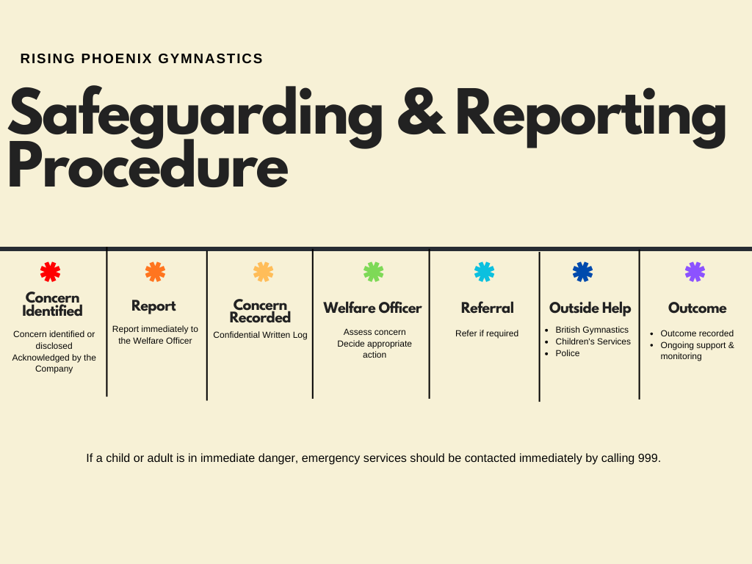
The safeguarding and reporting procedure is summarised below. Detailed guidance follows.

Detailed Procedure
Any employee, volunteer or coach who identifies or receives a safeguarding concern relating to a gymnast, employee, volunteer, parent/carer or visitor must report it immediately.
Concerns should be reported to a Club Welfare Officer as soon as possible by:
- Speaking to a Welfare Officer in person;
- Emailing the Welfare Officer; or
- Providing a written record of the concern.
The Welfare Officer will:
- Create a confidential written record of the concern;
- Assess any immediate risk to those involved;
- Determine the most appropriate course of action in accordance with British Gymnastics safeguarding guidance.
Where appropriate, the Welfare Officer may seek advice or make a referral to:
- British Gymnastics;
- Children's Services;
- The Police; or
- Other relevant statutory agencies.
Where a child or adult is believed to be at immediate risk of harm, emergency services should be contacted immediately by calling 999. This should not be delayed whilst attempting to contact a Welfare Officer.
The Welfare Officer will maintain confidential safeguarding records, monitor the outcome of any referrals and ensure appropriate follow-up action is taken where required.
All safeguarding concerns will be handled confidentially and information will only be shared with those who need to know in order to safeguard the individual concerned or fulfil legal and safeguarding responsibilities.
The Welfare Officer’s role is to receive the concern, assess the immediate risk, make a record, seek advice where appropriate and refer to the correct agency.

Contacts
Welfare Officers  Samantha Mulcahy  Holly Frew  Shelley Vann | risingphoenixwelfare@gmail.com
Northwest Region Welfare Officer  Mandy Horsefield | northwest.rwo@british-gymnastics.org
British Gymnastics | https://www.british-gymnastics.org/safe-and-fair-sport/policies-procedures  welfareandsafesport@british-gymnastics.org  bgcommunications@british-gymastics.org
NSPCC Helpline | 0808 800 5000
Emergency | 999

Related Documents
- Staff Handbook
- Staff & Volunteer Code of Conduct
- Safe Recruitment Policy
- Anti-Bullying Policy
- Social Media Policy
- Equality, Diversity & Inclusion Policy
- Complaints Procedure
- Whistleblowing Policy
- British Gymnastics Safeguarding Policies

