Policy Name: Anti-bullying Policy

Purpose
Rising Phoenix Gymnastics CIC is committed to providing a safe, respectful and inclusive environment where bullying is never tolerated. This policy is based upon British Gymnastics guidance and outlines how concerns will be managed within the club.

Scope
It is acknowledged that the competitive nature of sport can result in tensions that may lead to bullying but bullying cannot be condoned in any circumstances. Examples of bullying within gymnastics could be:
- A gymnast who intimidates fellow gymnasts inappropriately i.e. abusive text messages and/or through social networking sites.
- A coach who adopts a win-at-all costs philosophy i.e. shouting, name calling, or ignoring.
- A parent who pushes too hard i.e. shouting at a child.
- An official who places unfair pressure on a person.
- Older coaches intimidating younger coaches under the age of 18 years i.e. Senior coach shouting or intimating and assistant coach.
This policy applies to all gymnasts, parents, carers, employees, volunteers, directors, officials and visitors. Principles
- Provide an open environment and provide adequate supervision at all times.
- Encourage children to speak out and share any concerns with the person in charge, the Welfare Officer or other responsible adults.
- Take all signs or allegations of possible bullying seriously.

Policy Statement
Bullying within a club will never be tolerated.

Bullying may take many forms including physical, verbal, or through the written word, and may be conducted in person or through the actions of another person/other people.
Cyber bullying is now recognized as a serious concern and must be dealt with in line with the BG Anti Bullying policy.

Responsibilities

The Company:
- Take all concerns seriously
- Identify any ‘bullying’ situations within the gym
- Monitor on going situations which may already occur

Welfare Officer:
Keep accurate records of what happened together with names of those involved and any action taken.
- Inform the guardians
- Impose sanctions or disciplinary action if necessary.
- May consider holding a reconciliation meeting to help address the issues between the bully and the bullied young person.
Employee/Volunteer:
- Report suspicions or concerns to the person in charge.
- Explain the confidentiality of a member explaining their bullying may go to higher channels such as a lead coach & welfare officer

All staff and volunteers have the responsibility to identify, observe and record any forms of bullying

Procedure
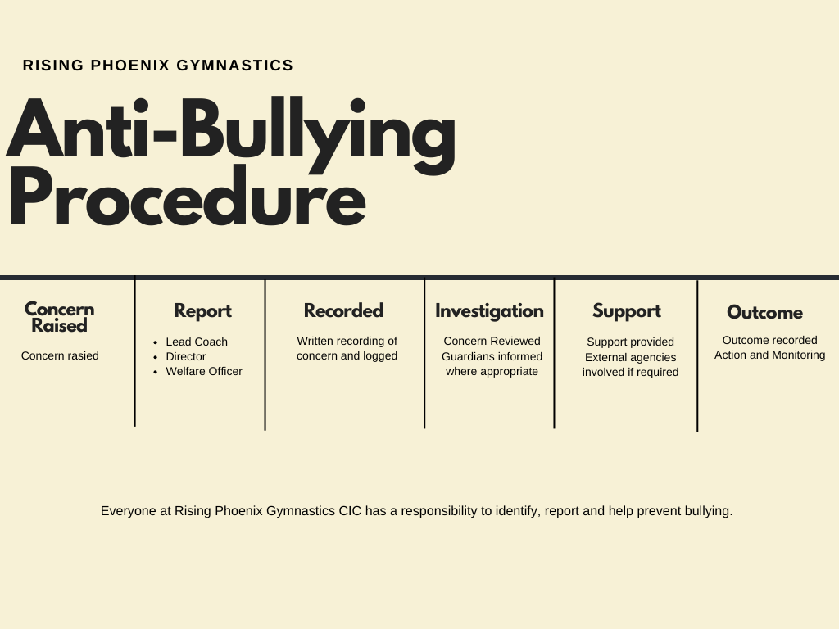

Related Documents
- Safeguarding

