Policy Name: Social Media Policy

Purpose
The purpose of this policy is to provide a recommendation of best practice to all members and parents on the use of social networking sites as they relate to individual’s roles in the club. If used correctly, social networking can be a fun, safe and productive activity.

Scope
As a user of a social networking site, whether you are a child, young person or an adult, you may at some time have a concern about what you are seeing or being told about by another user.

Concerns may range from negative or abusive comments and cyber bullying to suspected grooming for sexual abuse.

Policy Statement
We have our own Public Social Media and Website to advertise and celebrate the achievements of the Gymnastics, coaches and club.

Upon signing up to Rising Phoenix CIC everyone is given the option to ‘opt in’ or ‘opt out’ of being included in our Public Social Media and Website.

The club expects all users of social media to act respectfully and protect the welfare, privacy and reputation of all members. Responsibilities
All Over 18’s- Directors, Members, Employees, Volunteers, Judges

- Adults in a position of trust and/or responsibility (as defined in the British Gymnastics Safeguarding and Protecting Children Policy) should not be in contact with any young people through any social networking sites whether the young person is a member of their club or any other club.
- If a young person requests to become a named friend on your Social Networking Page or request that you become a named friend on their Social Networking Page you should decline as you are in a position of trust and responsibility.
  - As a British Gymnastics registered club this is against their guidance policy for social media.
- The above also applies to official club social networking sites. Only club staff and parents should be permitted access.
- Social networking sites should never be used as a medium by which to abuse or criticise any member of the club.
  - To do so would be in breach of British Gymnastics Standards of Conduct.
- The publishing of a photograph or video footage on a social networking site is governed by the same requirements as any other media. All participants in the video/photo should have permission to be used on public social media and websites.
  - Only staff members who have access to our club's social media can post and therefore, it is their reasonability to check if the participants have permission.
All Under 18’s- Directors, Members, Employees, Volunteers, Judges
- We recognise social networking sites can be a useful tool for judges, coaches and officials to share information with others only if written consent of the parent/guardian and young person to have such contact naming the individual adult and social networking site concerned
  - The named adult must sign an agreement to keep the contact with the young person to the discussion of matters relevant to the young person’s professional role in the club.
  - All communication should be shared with an identified 3rd person (e.g.the young person’s parent/guardian or Club Welfare Officer)
  - If the young person or the adult is found to breach the above agreement:
    - Action must be taken by the club to cease connection.
    - Be referred to British Gymnastics for further consideration and action.
The Child Protection in Sport Unit (CPSU) provides a wealth of advice and guidance. In particular, their website provides additional guidance regarding social networking services, social media and sport. It can be accessed via http://thecpsu.org.uk

Procedure
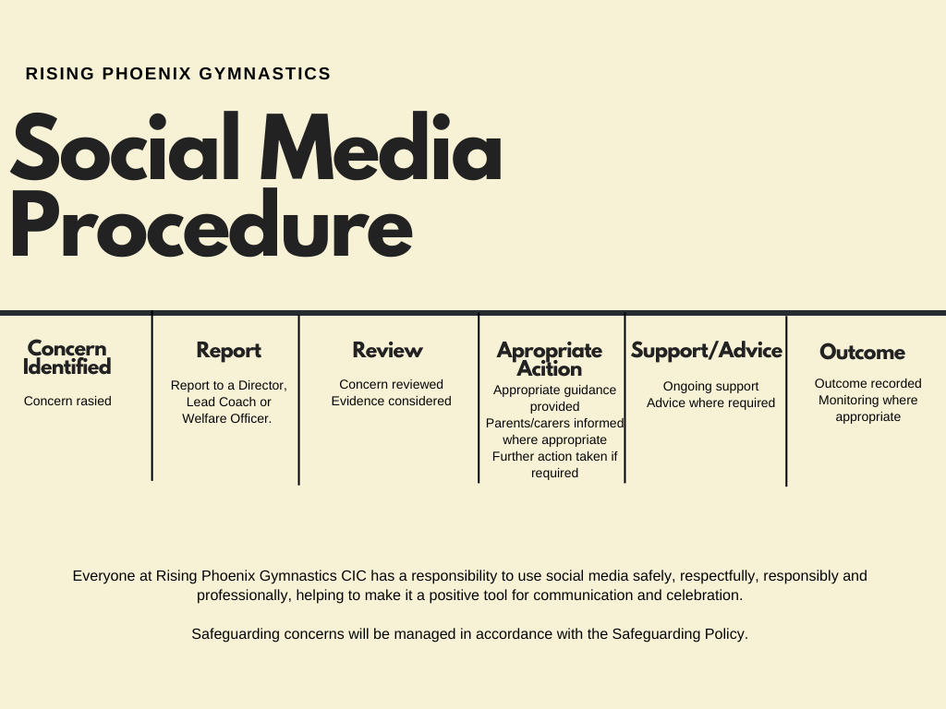

Procedure Details
In addition, British Gymnastics has compiled a list of agencies that can be contacted, anonymously if you wish, where such concerns can be raised:
- www.thinkuknow.co.uk - the main UK Government website with advice for parents on how to keep children safe online.
- www.ceop.police.uk - the Child Exploitation and Online Protection Centre (CEOP) is the Government body dedicated to eradicating abuse of children. Concerns about inappropriate contacts between a child and an adult, including online, can be reported directly to CEOP. Reporting can be accessed by pressing the CEOP button on the BG website’s CEOP page.
- www.iwf.org.uk - the Internet Watch Foundation (IWF) works to remove illegal material from the internet. If you have found any material you believe to be illegal e.g. child sex abuse images, other obscene material or material which incites racial hatred, you can report it to the IWF.
- A number of specialist websites contain general advice that may be of help to parents. These include:
  - www.nspcc.org.uk
  - www.barnardos.org.uk
  - www.beatbullying.org
- Other sites can offer parents support on broader issues. These include https://www.familylives.org.uk/
- British Gymnastics Safeguarding and Compliance Team on 0345 129 7129 ext 2346
- Childline 0800 1111 or www.Childline.org.uk is another NSPCC support service. Using this website, children can talk confidentially to NSPCC advisors online about any issues or problems they may be experiencing, using an application similar to Instant Messenger (IM).
- Stop It Now freephone 0808 1000 900 or www.stopitnow.org.uk
- The Local Police
- If you are unsure of the force you need to speak to, call 101 and theywill direct you or in an emergency situation, call 999.
- Local Authority Children’s Services are available for advice and guidance – their number appears in the phone book.

Related Documents
- Safeguarding
- Anti-bullying
- Staff Handbook
- Code of Conduct

