Policy Name: Complaints Policy

Purpose
To provide a fair, transparent and consistent process for managing complaints raised by parents, gymnasts, members, volunteers or members of the public.
Rising Phoenix Gymnastics CIC aims to resolve concerns promptly, respectfully and fairly while using feedback to improve the service we provide.Scope
This policy applies to:
- Parents and carers
- Gymnasts
- Adult participants
- Volunteers
- Visitors
- Members of the public
It does not apply to:
- Staff grievances (see Grievance Policy)
- Safeguarding concerns (see Safeguarding Policy)
- Disciplinary matters involving staff (see Disciplinary Policy)

Policy Statement
Rising Phoenix Gymnastics CIC welcomes feedback and recognises that concerns or complaints may occasionally arise.
We are committed to listening, investigating concerns fairly and responding in a timely and respectful manner.
Where possible we encourage concerns to be raised informally first so they can often be resolved quickly.
No person will be treated unfairly for raising a genuine concern.
We value feedback and view complaints as an opportunity to improve the experience we provide for every gymnast and family.

Responsibilities
Directors
- Ensure complaints are handled fairly.
- Ensure appropriate investigations are completed.
- Maintain confidential complaint records.
- Identify improvements following complaints.
Staff & Volunteers
- Treat all complaints respectfully.
- Report complaints promptly.
- Cooperate with investigations.
Parents & Members
- Raise concerns politely and honestly.
- Provide relevant information where possible.
- Allow reasonable time for investigations.

Procedure
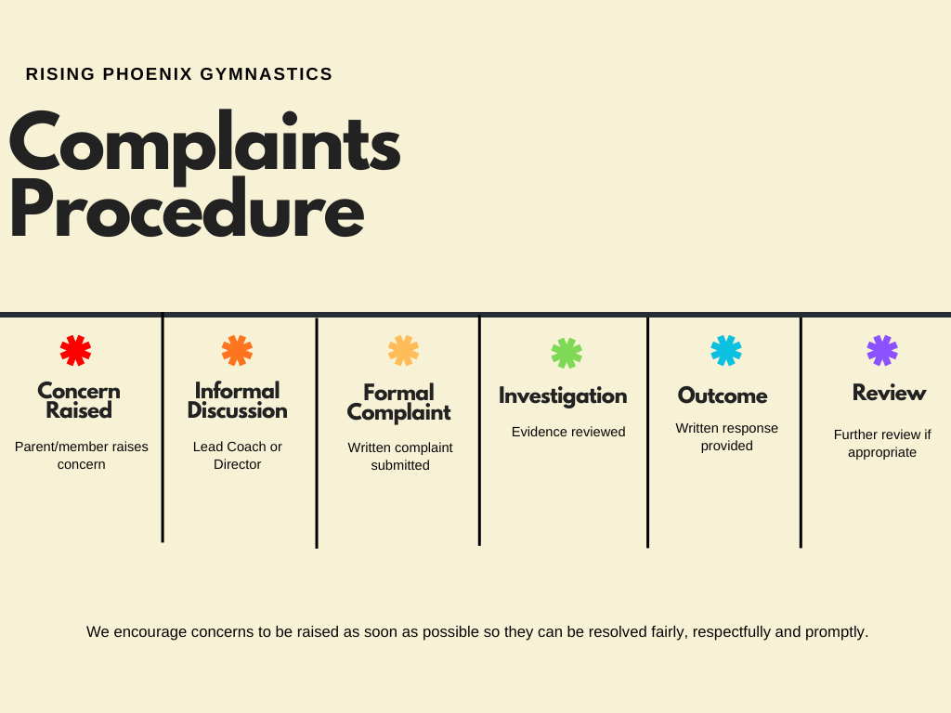

Detailed Procedure
Stage 1 – Informal Concern
Where appropriate, concerns should first be raised with:
- The Lead Coach
- A Director
Many issues can be resolved quickly through discussion.
Stage 2 – Formal Complaint
If the concern cannot be resolved informally, a written complaint should be submitted by email or letter. The complaint will normally be acknowledged within 5 working days.
The complaint should include:
- Name
- Contact details
- Description of concern
- Relevant dates
- Desired outcome (if appropriate)
Stage 3 – Investigation
The complaint will be acknowledged.
An appropriate Director will:
- Review the information
- Speak with relevant individuals
- Gather evidence
- Keep records
Where appropriate, safeguarding or disciplinary procedures may be followed instead.
Stage 4 – Outcome
We aim to provide a written outcome within 20 working days, although more complex complaints may take longer. Where this happens, updates will be provided.
A written response will normally be provided explaining:
- Findings
- Any actions taken
- Any improvements made (where appropriate)

Stage 5 – Appeal
If the complainant remains dissatisfied, they may request a review by another Director (where possible).
The outcome of the review will normally be considered final unless significant new information becomes available. Confidentiality
All complaints will be handled confidentially and information shared only with those who need to know. Information will only be shared with those who need it in order to investigate or resolve the complaint.
Related Documents
- Safeguarding Policy
- Grievance Policy
- Disciplinary Policy
- Equality, Diversity & Inclusion Policy
- Staff Code of Conduct

